Stepwise Refinement Approach

# Level 1 (High-Level Abstraction)

The first level of the stepwise refinement approach involves understanding the overall task at a high level. The goal is to convert a numeric amount, such as 1245.67, into its written text equivalent, such as "One Thousand Two Hundred Forty-Five Dollars and Sixty-Seven Cents."

## Input and Output

* Input: A numeric amount (e.g., 1245.67)
* Output: The written text amount ("One Thousand Two Hundred Forty-Five Dollars and Sixty-Seven Cents")

# Level 2 (Medium-Level Abstraction)

At this level, we break down the task into more manageable parts. This involves separating the numeric amount into its integer (dollars) and fractional (cents) components and converting each part into words.

## Steps:

* Parse Integer and Fractional Parts: Identify the dollars and cents separately from the numeric input.
* Convert Each Part into Words: Use standard conversion techniques to translate numeric values into written text.
* Format Output Properly: Ensure the final output is correctly formatted, appending "Dollars" and "Cents" as appropriate.

# Level 3 (Low-Level Abstraction)

The third level delves into the specific details of the conversion process. This includes handling different numeric ranges and special cases, such as teens (11-19), and ensuring the correct terminology is applied.

## Detailed Steps:

* Handle Ones, Tens, Hundreds, Thousands Separately: Convert each numeric segment based on its place value (ones, tens, hundreds, thousands).
* Special Handling for Teens (11-19): Apply unique conversion rules for numbers between eleven and nineteen.
* Append "Dollars" and "Cents" Correctly: Ensure that the terms "Dollars" and "Cents" are appended appropriately to the converted text.
* Handle 0 Cents and 0 Dollars Appropriately: Include special rules to manage cases where the cents or dollars amount is zero.

Execution



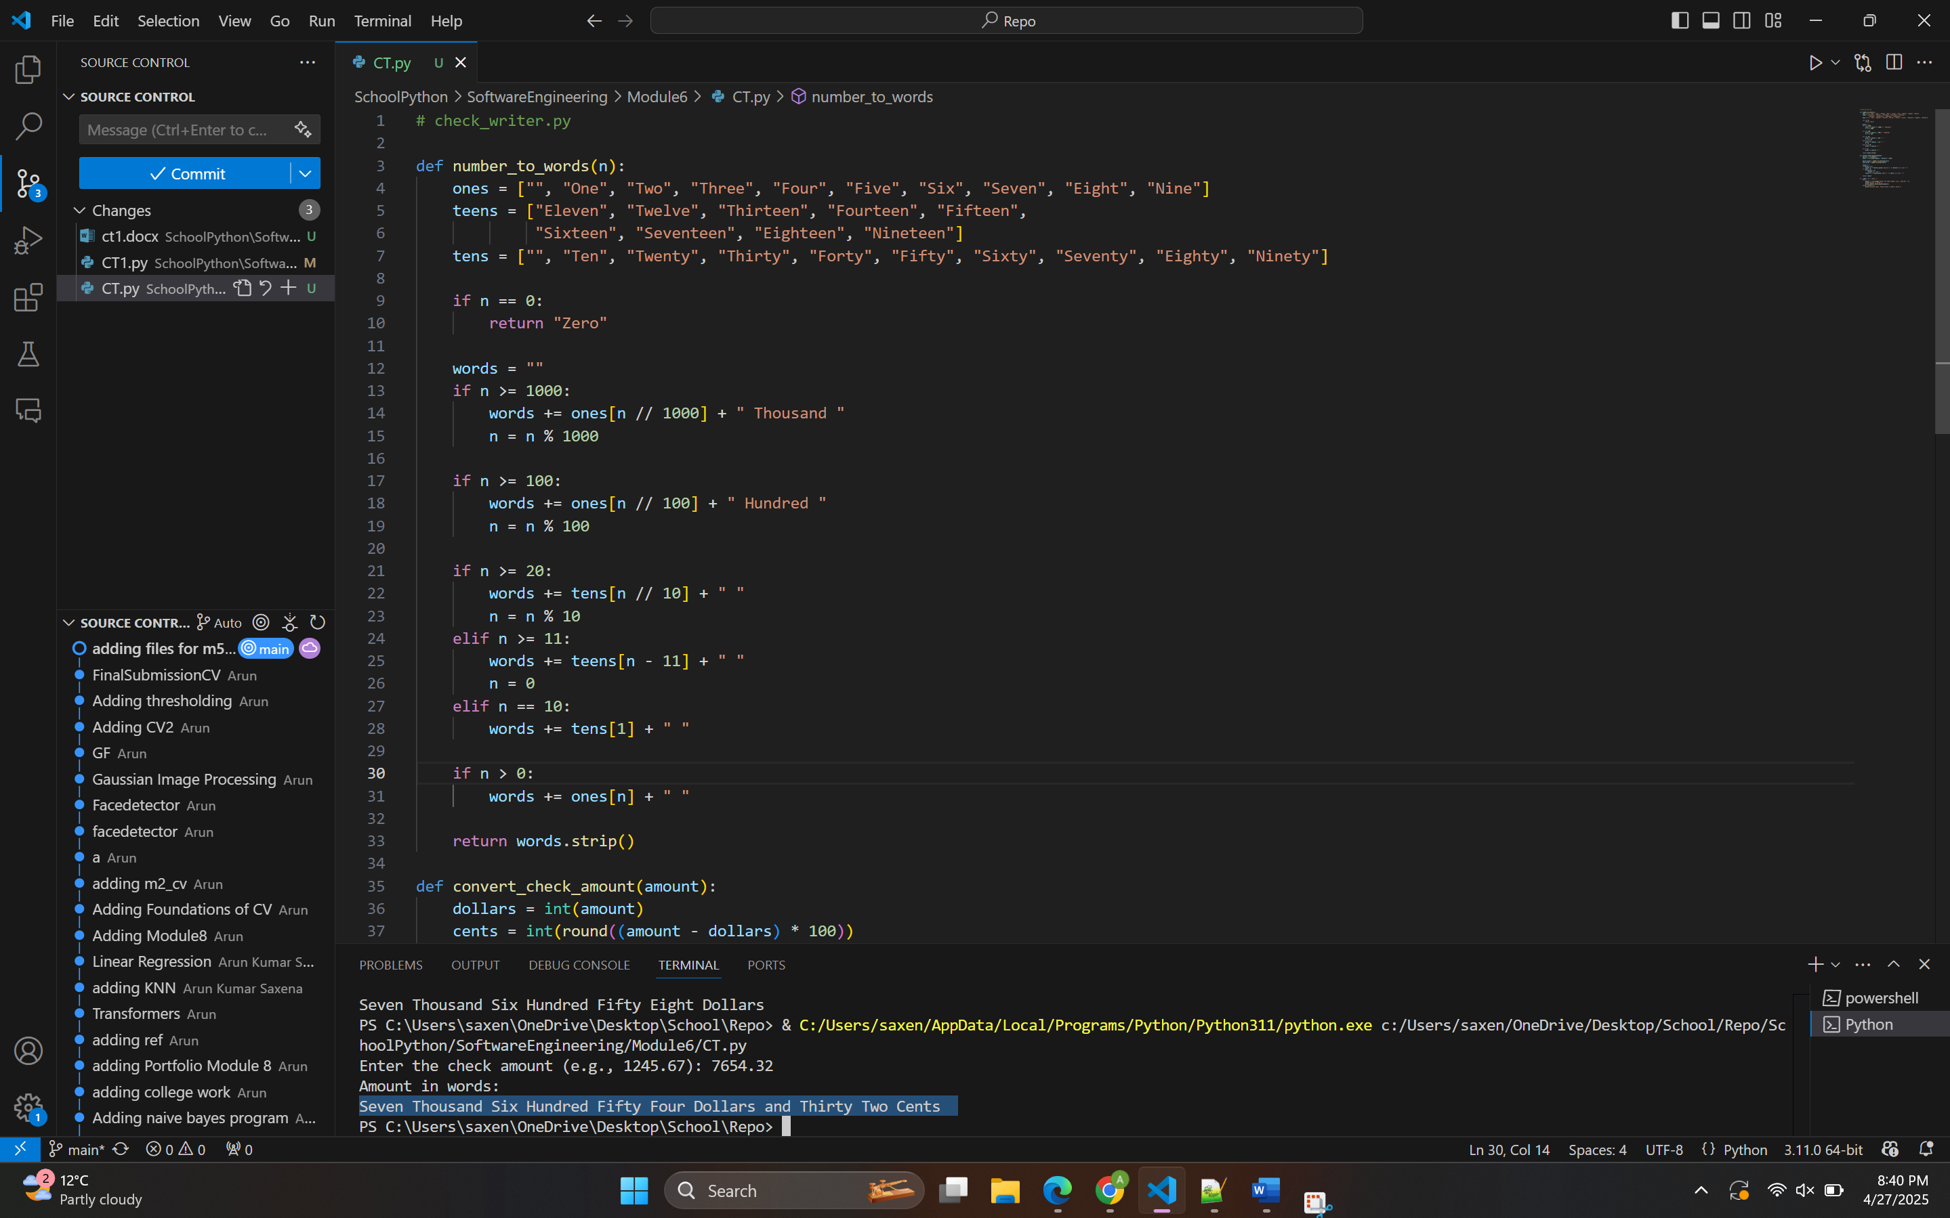

# Conclusion

The stepwise refinement approach is a powerful technique for solving complex problems by breaking them down into smaller, more manageable parts. By applying this method to the task of converting numeric amounts into written text, we can ensure a systematic and accurate conversion process.

By addressing each level of abstraction—from high to low—we achieve a comprehensive and precise method for translating numeric values into their corresponding textual representations, ensuring clarity and correctness in financial and other numerical contexts.

# References

* Knuth, D. E. (1997). The Art of Computer Programming, Volume 1: Fundamental Algorithms. Addison-Wesley Professional.
* Pressman, R. S. (2014). Software Engineering: A Practitioner's Approach. McGraw-Hill Education.
* Wirth, N. (1971). Program Development by Stepwise Refinement. Communications of the ACM, 14(4), 221-227.